

**Dates for your diary**

3rd September – Autumn term begins

19th September – FOSBNS Welcome Evening 4pm-6pm

28th September – Macmillan Coffee Morning 9am-11am – all welcome

Tuesday 30th October – Halloween tea party – 4pm-6pm, all welcome.

25th November – *FOSBNS Christmas Fair*

Monday 3rd & Tuesday 4th December 9am-9:45am – Christmas *Stay and Play –* 2 adults per child. Please speak to a member of staff to arrange which session you can attend.

Nursery closed: Tuesday 25thDecember – Wednesday 2nd January

7th January 2019 – Spring Term

Baby Signing: Each month we will practise a new sign with children. This month we are learning hello and goodbye. Please ask a member of staff to demonstrate and send us photographs of your child signing, via Parentzone.

A warm welcome to all our new starters in ***The******Streams***. We look forward to getting to know you all! We also welcome Miss Harrop to our team!

We are always looking for loose parts and natural objects to be used in heuristic play and to add to our Treasure Baskets. If you have any of the following lying around, please donate them to nursery.

* Pinecones
* Shells
* Watches
* Ribbons
* Egg cups
* Wooden spoons
* Material
* Small mirrors etc.

The FOSBNS are still looking for more parents to get involved with fundraising events and ideas. Why not join them and get to know some friendly faces? Follow their FB page for updates and upcoming events!

**Baby Room Project!**

As you may already know, we are delighted to have been chosen to be part of Durham’s Baby Room project 2018! The project aims to empower staff to be more reflective in their practice and to improve and enhance the way we work with babies. Thank you so much for your feedback and involvement so far. We really do want to be the best that we can be and offer our babies a quality experience here at nursery.

To promote children’s learning we like to follow their own interests when planning activities. We really appreciate any pictures and videos of activities children take part in at home being sent through the ParentZone app. These images also aid observation of aspects of development which we may not have witnessed at nursery. Reminders:

* All items to be clearly labelled when brought in (including nappies, wipes etc.).
* Can children who attend full-day sessions bring in a toothbrush and toothpaste (labelled).
* Outdoor shoes cannot be worn in the room – please provide slippers.
* Formula must be unopened when brought in.
* We go outdoors in all weathers and as winter is approaching please ensure children have suitable clothing and footwear.
* Once your child is drinking water, please bring a named water bottle/cup with fresh water each day so they have free access to it.

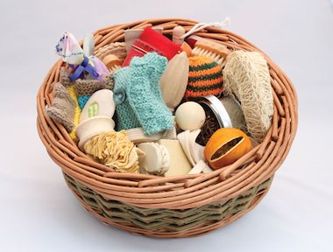

**For obvious security reasons, please could we urge you not to let anyone else into nursery once you have been buzzed in. We know that this may feel impolite but it is highly important that staff only buzz in one person at a time. If someone does hold the door for you please decline and buzz the room yourself.**

If you haven’t signed up to the parent zone or are unsure how to do so, please speak to our manager Mrs Wilkinson.

Remember to check out our Facebook page for regular updates about what is happening!

*The Streams*

Newsletter: Autumn 2017

