The Bridges - Newsletter
Autumn Term 2016
Food Donations
To celebrate harvest this year we are asking for dried/tinned food donations w/c 26th September for your child to deliver to Consett Foodbank. This will help the children to learn about helping people in the community.
Environmental Print
To support the children’s literacy development we would like to put together an alphabet book of logos and food labels. Please can you save your labels and packaging and bring them into the nursery. Examples are McDonalds chip packet, Milky Bar wrapper, Weetabix box etc.
What we need
We like to use loose parts to promote our learning and we would like to extend a few of our collections with your help:
- Old Pots and Pans
- Paper Plates
- Old Kitchen Utensils
- Wool

Welcome Back
We would like to take this opportunity to welcome you back to our room. We hope you have had a wonderful summer and we are looking forward to listening to your adventures.
Super Learners
You will notice that your child has a superhero on their ducket. This is your child’s secret identity as when they come to nursery they turn in to SUPER LEARNERS! They will need to self-register when they come into nursery by picking up their superhero and sticking it on the side of the wardrobe to show that they are here and ready to learn and have fun.

Bridge Photographs
We love the children to feature in our room and would like to put a picture of your child on a bridge, on our notice board. When out and about can you take a photo of your child and place it in their key person’s box please?
Scarecrow
We will be building a scarecrow w/c 5th September which will be displayed in the Tanfield Scarecrow Festival. The festival will be taking place 10th/11th September and our scarecrow will be displayed along the road into Tanfield from Tantobie. Why not go and see if you can find it with your family?
Any Other News
Please remember to name all of your child’s belongings.
Water bottles need to be taken home on a daily basis so they can be cleaned and replenished with WATER.
We have a lot of children bringing toys in from home. Unfortunately we do not have the space to store them and cannot promise that they will not get lost or broken which can cause some upset. We advise that toys remain at home.
We need to replenish our stock of spare clothing (age 3-5) If you have any donations of socks, pants and trousers we would be very grateful.
Beginning of term equipment your child will need to bring:
- Slippers
- Wellington boots
- Sun cream
- Pack of baby wipes
- Tooth brush and tooth paste if your child stays for lunch
- Water bottle (to be taken home each day)
- Change of clothes (we do get a little messy)
Please make sure all items are named

What we are Learning
September – ‘Supertato and the Veggie
Assemble’
We will be learning about a range of fruit and vegetables, growing sweet potatoes, building a scarecrow, conducting some science experiments, capturing evil peas and visiting a foodbank amongst other exciting activities linked to this story

October – ‘The Brilliant Beast’

November – ‘My Grandpa’s Amazing
Inventions’

Each week we will learning about a letter and number, starting with the letter ‘A’ and number ‘1’.

Each week we will be posting a blog on Parent Zone to inform you of the learning that is taking place in our room.

Parent Zone is a fabulous tool that you can also use to share news, accomplishments and proud moments with your child’s key person. Please feel free to send photos and/or comments through the Parent Zone about what you have been doing at home or out and about.

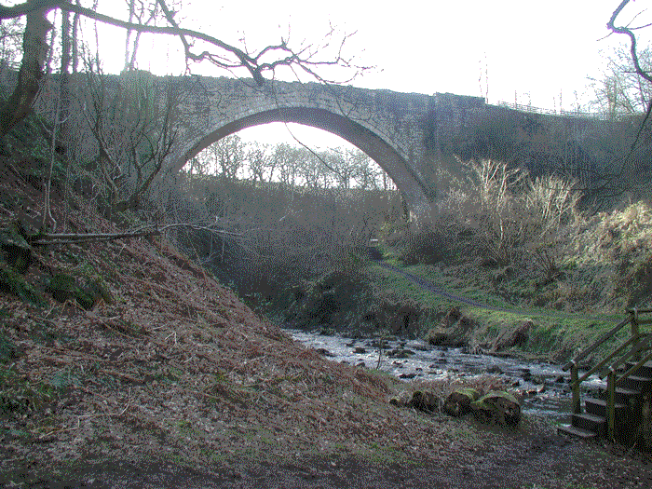
Guess the Bridge?

Reminders: For obvious security reasons, please could we urge you not to let anyone else into nursery once you have been buzzed in. We know that this may feel impolite but it is highly important that staff only buzz in one person at a time. If someone does hold the door for you please decline and buzz the room yourself. Thank you to everyone who remembering to follow procedure!
If you haven’t signed up to the parent zone or are unsure how to do so, please speak to our manager Mrs Lant. It is also important that you let us know if you are experiencing any difficulties so that we can try to rectify the problem.
Remember to check out our Facebook page for regular updates about what is happening in nursery.
F.O.S.B.N.S – The Friends of Shotley Bridge Nursery are always looking for volunteers! Please ask a member of staff for details on how to join our check out their Facebook page. Simply search for the above.
Uniform – Tesco are now able to offer uniform from age two: tesco.com/ues
Please remember to label all clothing and dress your child in clothing that is weather appropriate – we go outdoors in all weathers.
Please be aware that for safeguarding reasons mobile phone use is not permitted anywhere within the nursery.

Dates for your diary
Start of term – 5th September
Macmillan coffee morning - Friday 30th September
The Big Ghost Toddle for Barnardo’s - 31st October
Half term 24th October – 28th October
FOSBNS Christmas Fun Day - Sunday 6th November
Nursery Christmas Fayre -20TH November
Christmas concert – Wednesday 24th December
Christmas party -Thursday 15th December
Nursery closed for Christmas - Monday 26th returning on Tuesday 3rd

