



**Dates for your diary**

Wed 13th September 11:15am-1:15pm FOSBNS will be in the hall giving away free fruit to the children

Fri 29th September – Macmillan Coffee morning -9:30am – 11am

Half term – Monday 23rd – Friday 27th October

Halloween Tea Family Event Monday 30th October 4-6pm

Christmas Winter Wonderland painting activity – 11th & 12th December

Break up for Christmas Friday 22nd December

Nursery reopens Tuesday January 2nd

Funded term starts Monday 8th January

The FOSBNS are still looking for more parents to get involved with fundraising events and ideas. Why not join them and get to know some friendly faces? Follow their FB page for updates and upcoming events!

We would like to display pictures of children’s families around the room to provide familiarity and encourage the development of communication and language skills. Please can you either bring in some family photos or send them via the Parent Zone app with details of who is in the pictures.

To promote children’s learning we like to follow their own interests when planning activities. We really appreciate any pictures and videos of activities children take part in at home being sent through the Parent Zone app. These images also aid observation of aspects of development which we may not have witnessed at nursery.

Reminder:

* All items to be clearly labelled when brought in (including nappies, wipes etc.).
* Can children who attend full-day sessions bring in a toothbrush and toothpaste (labelled).
* Outdoor shoes cannot be worn in the room – slippers are optional but most children prefer to be barefoot.
* Formula must be unopened when brought in.
* We go outdoors in all weathers and as winter is approaching please ensure children have suitable clothing and footwear.

A warm welcome to all our new starters in The Streams: Joseph, Harry, Hudson, Florence, Daniel, Sadie, Joey, Brooklyn, Gabriel, Caspian, Alasdair and Axel.

Children transitioning to Rivers – Toby, Ollie, Lydia, Ava, Joseph and Cooper.

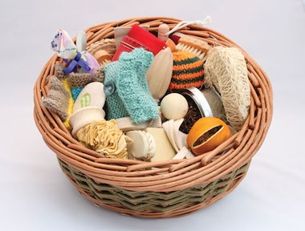

We are always looking for loose parts and natural objects to be used in heuristic play and to add to our Treasure Baskets. If you have any of the following lying around, please donate them to nursery.

* Pinecones
* Shells
* Watches
* Ribbons
* Egg cups
* Wooden spoons
* Material
* Small mirrors etc.

**For obvious security reasons, please could we urge you not to let anyone else into nursery once you have been buzzed in. We know that this may feel impolite but it is highly important that staff only buzz in one person at a time. If someone does hold the door for you please decline and buzz the room yourself.**

If you haven’t signed up to the parent zone or are unsure how to do so, please speak to our manager Mrs Wilkinson.

Remember to check out our Facebook page for regular updates about what is happening!

*The Streams*

Newsletter: Autumn 2017

