Bridges Newsletter

May 2017

|  |
| --- |
|  |

What we need

We like to use loose parts to promote our learning and currently we would like to extend a few of our collections with your help:

* Cardboard tubes
* Paper Plates
* Green Wool
* Cotton Wool
* Non working electrical equipment

‘Jolly Phonics’

As part of our learning in literacy we have been exploring the ‘Jolly Phonics’ phase 2 songs as well as looking at the actions that accompany the letter sounds. These sounds support the children to identify the different initial sounds in words, for example the initial letter in their name and, when they are ready, put two/three letter sounds together to sound out a word. If you require any more information on ‘Jolly Phonics’, please speak to Mrs Cooper.

WOW Moments

We love the wow moments that you have been sharing. As well as learning about your child’s achievements, those small pieces of paper give your child a sense of pride. Please continue to share; the slips of paper are available in the room. Alternatively you can also post your child’s wow moments on the parent zone.

The Sun Has Got His Hat On

We know that summer seems like a fairytale, especially when we were having snow showers last week, but the British weather has never been predictable so we would like you to provide sun protection for your child. Please can you supply a bottle of sun-cream, marked with your child’s name. As well as a named sun-hat, so we can be prepared for the summer. It would also be helpful if you could ensure your child has sun-cream on when they come to nursery so they are protected before they go out into the sun.



Soft Wood Needed

We have been engaging in woodwork activities and we are quickly running out of soft wood, such as Cedar, Fir and Pine. If you or someone you know, have access to soft wood we would be very grateful of donations. The children would like to access this resource independently and wood is a fantastic media for open-ended creativity, so we would like to create a good stack of a variety of off-cuts in different shapes and sizes.

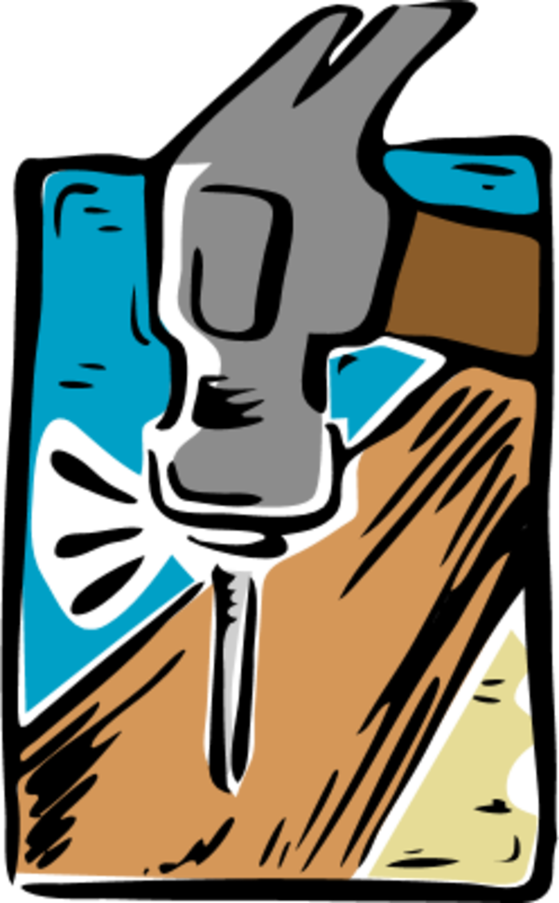

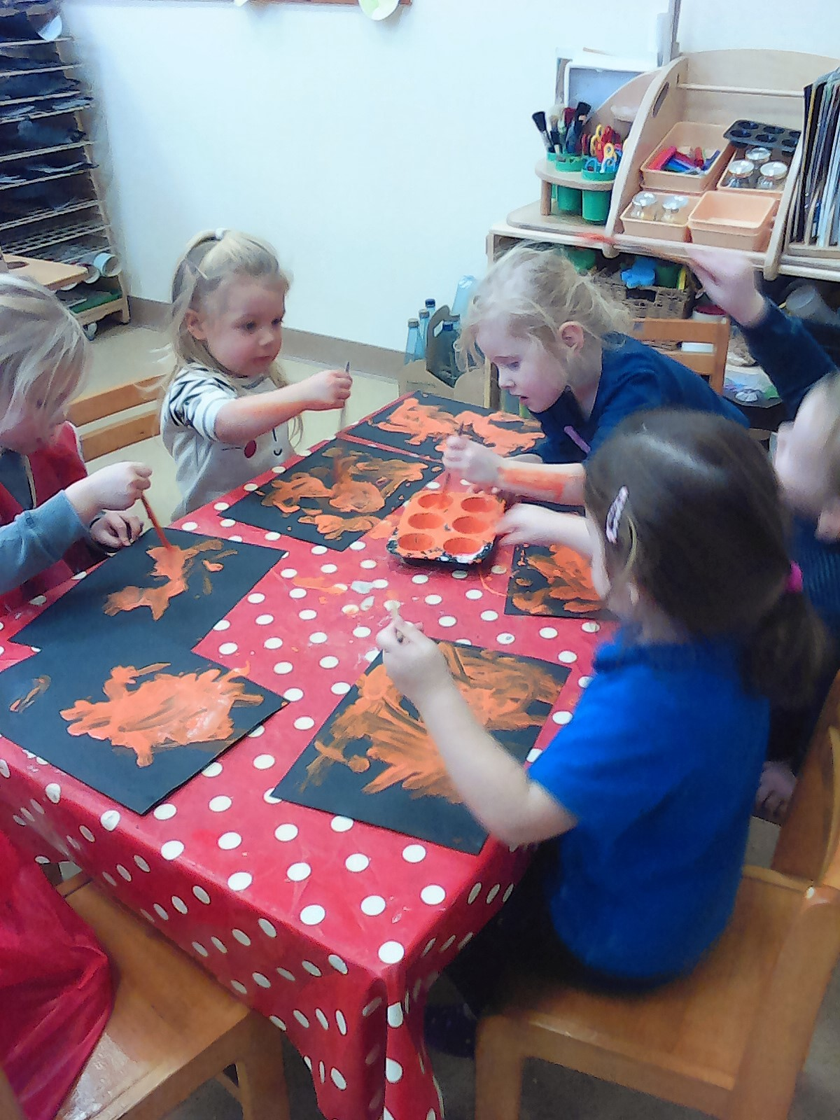

Dates For Your Diary

29th May – 2nd June – Half Term

6th June – Ben and Jet Visit

8th June – Fire-fighters Visit

9th June – Dough Disco Day

16th June – Fathers Day Wood Work Afternoon

19th July – Leavers Graduation

21st July – End of Summer Term

Any Other News

Please remember to name all your child’s clothing.

We have a lot of children bringing toys in from home, unfortunately we do not have the space to store them. Please can toys remain at home.

Please can you send in a named pack of baby wipes with your child.

During sessions we play in all weathers and sometimes we can get wet/messy. Please can you make sure your child brings spare clothing in their bag.

The weather has changed, please be mindful of this when dressing your child. The children have free access to the outdoors so will need appropriate outdoor clothing.

Remember to provide your child with a named water-bottle. The bottle needs to be taken home daily to be washed properly as there have been reports of bacteria building up around the mouth pieces unless washed thoroughly.

Please also remember your weekly £1 donation to the Children’s Fund. This is vital in being able to provide your child with all the added extras our nursery offers.

Remember to follow us on Facebook!

What we are Learning

***Multicultural May***

Week 1 – Languages

Week 2 – Music

Week 3 – Homes

Week 4 - Food

***Exploring the Community June***

Week 1 – People who help us

Week 2 – People who help us

Week 3 – Our Community

Week 4 – Our Community

***Learning New Skills July***

Throughout July we will be focusing on some skills we can learn and practise that will help us to be more independent and ready for school!