Summer Term 2016 Newsletter
The Bridges

Guess the Bridge?

Upcoming Events

April 22
St George’s Day Celebration

June 11
Queen’s 90th Celebration

June 17
Father’s Day Celebration

July 18
Leavers Outing

July 19
Leavers’ Graduation

July 20
End of Summer Term

September 4
Autumn Term Begins

Welcome
Firstly we would like to welcome the children and their families joining our room this term. We have lots of fun things planned over the next 14 weeks in both the indoor and outdoor environments. We would also like to welcome Mrs Dial and Miss Allum to our room. Mrs Dial has trained as an Early Years Practitioner in Australia and as well as a wealth of experience she brings new songs, stories and children’s yoga to our daily routine. Miss Allum has a BA in Early Years Education and brings lots of enthusiasm and new ideas!
Duckets and Slipper Racks
As more children have joined our room we have had to change how we store our shoes and slippers. Some children will be sharing pegs, as they are in on different days. From Monday 11th April children’s shoes are to be kept on the floor under their pegs. Their slippers will be in one of the new racks by the door and the duckets are to be used for the children’s work and letters.

Milk Bottle Tops
We have lots of creative ideas for milk bottle tops in various colours. Please can you bring in any you may have and place them in the labelled basket.

Queen’s 90th Celebrations
We will be having a party on Saturday 11th June to help Queen Elizabeth celebrate her 90th Birthday. Please put this date in your diary. More details of this fun event will follow soon.
Father’s Reading Week
This year we will be combining Father’s day with the Fatherhood Institute’s reading week. During w/c 13th June we will be looking for any of the children’s fathers or a male family member to come and read. On Friday 17th at 3pm we will be having a small picnic on the green to celebrate our week of stories. Invitations to follow.

WOW Moments
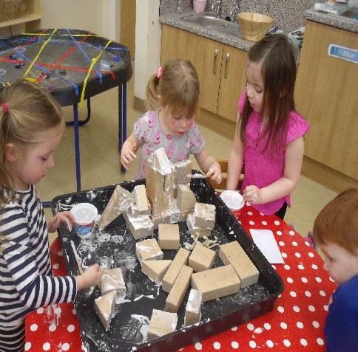

Any Other News
Please remember to name all your child’s clothing.
Please can you take your child’s water bottle home on a daily basis so they can be cleaned and replenished with WATER!
We have a lot of children bringing toys in from home, unfortunately we do not have the space to store them. Please can toys remain at home.
Please can you send in a named pack of baby wipes with your child.
We are still collecting photographs of your child on a bridge for our notice board.
We need to replenish our stock of spare clothing (age 3-5) If you have any donations of socks, pants, trousers and tops we would be very grateful.
We are in the process of updating our calendar and have lots of exciting events coming up. Please keep an eye out for emails and letters in the next few weeks.

We love the wow moments that you have been sharing. As well as learning about your child’s achievements, those small pieces of paper give your child a sense of pride. Please continue to share; the slips of paper are available in the room.
What we need
We really like to be creative! It promotes our learning and currently we would like to extend a few of our collections with your help:
- Paper
- Paper Plates
- Card
- Paint
- Magnetic Letters
- Small World Figures and Animals
- Old tea-towels or hand towels

Breakfast
Please be aware that we stop serving breakfast at 8.15am. If your child arrives after 8.15am breakfast will have been cleared away and the daily activities will have begun.

Healthy Week
On Monday 18th April we will be taking part in the NDNA’s Healthy Body, Happy Me Campaign. Each day of the week-long campaign has a special theme promoting healthy messages with fun activities, tips and ideas. Please see our notice board for more details.
Invictus Games
On 8th-12th May the Invictus Games take part in Orlando Florida. We will be learning about the games to enhance the children’s knowledge of sport and disability. During the week the children will have the opportunity to watch some of the games and use some mobility equipment, as well as trying to do simple tasks without using their hands/voice/hearing.
What do our parents do?
Next week we will send out a form in your child’s ducket asking about the occupations of those in your family. It is important that the children develop their understanding of different occupations so we would like to find out about the different occupations in the area and in some cases invite you in to tell us all about it.
Parent’s Zone
Please remember that you can use parent zone to send us information/pictures about you child. We love to see how they are learning and exploring when they are with their family. If you are experiencing any problems, please speak to our manager Mrs Lant.
St George’s Day
To celebrate St George’s Day this year we will be wearing red on Friday 22nd April.

Anything Else!
Remember to check out our Facebook page for updates and photographs about what is happening in nursery! Our new Summer menu is now available to download from our website.
Please also be aware that for safeguarding reasons, mobile phone use is not permitted anywhere within the nursery. It is also very important that when entering nursery you do not let other people in behind you. Each person must buzz their room separately so that staff know they are coming and to ensure the safety of the children.
FOSBNS
£859 was raised by the sponsored Easter Bunny Hop organized by Mrs. Metcalf. Thank you so much for all her hard work! This will go a long way to helping buy some staging for future performances!
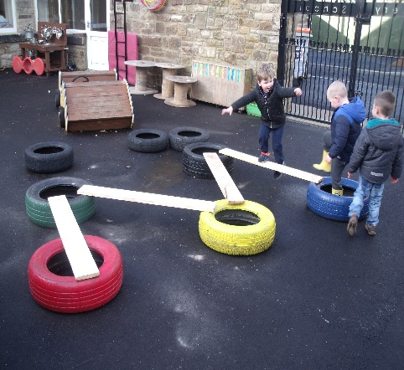What we are learning
April
11th – 22nd: Letter A - D
Number 16/17
Handa’s Surprise – Learning about health and wellbeing

April - May
25th -6th Letter E-H
Number 18/19
Chicken Licken – Learning about rhyme

May
9th – 20th Letter I-L
Number 10/20
Max the Champion – Learning about sport and disability

23rd – 27th Letter M-P
Number 0
The Smartest Giant in Town – Learning about size and helping others

May – June
30th – 3rd HALF TERM

June
6th – 17th Letter Q-T
Number 1 - 5
Daddy is My Hero – Learning about positive male role models

June- July
20th – 1st Letter U-W
Number 6-10
The Hungry Caterpillar – Learning about changes and healthy Eating

July
4th – 15th Letter X-Z
Number 11-20
Topsy and Tim go to School – Learning about big school!

