The Rivers - Newsletter - Spring term

Happy New Year everyone and a warm welcome to all our new starters!

Thank you for all your support last term. Our Halloween Ghost Hunt was a great success and raised £140 for Barnardo’s. We also had a fabulous time at Christmas and our sing-along in the park had an excellent turn-out with lots of good feedback from parents.
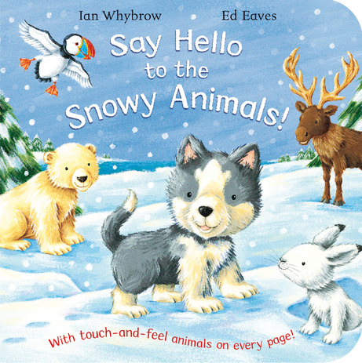
This term our topic related books will be:
- Say Hello to the Snowy Animals
- Guess How Much I Love You
- Goldilocks & The Three Bears
- Hooray For Fish

We will also be recognising several celebrations over the coming weeks including:
- Chinese New Year – food tasting and making money envelopes
- Valentine’s Day – various arts and craft activities
- Mardi Gras – dancing and creative experiences

Maths Challenge!
We continue to be part of the NDNA Maths Championship in conjunction with Durham University for which our nursery was specially selected! This term we are looking at number recognition, counting in sequence, quantities and shapes. We have recently provided some bath time activities for you to do at home to support your child’s learning. We would appreciate donations of the following resources if you have any lying around: clocks, timers, shapes, tape measures, rulers.

Please remember our door policy and procedure. You must buzz the room individually and not let other people in at the same time. This is for safeguarding purposes. We appreciate that people are often in a hurry but please respect this system. On occasion parents have experienced someone being rude and aggressive when they have shut the door behind them. This is NOT ACCEPTABLE.

Follow us on Facebook and our website for more updates and photos of what is happening at nursery!

We would like to organise a bus trip to the Blue Reef Aquarium in Tynemouth on Saturday 6th May 2017. There will be a cost for adults and children over 3 but all children under 3 go free. The price overall will be dependent on the number of people who wish to go, so please speak to a member of staff if you are interested. More information will follow once we have an idea of final numbers.

Firefighters Clothing Collection

We are collecting unwanted clothing for the Firefighters charity. Bags will be placed in duckets for you to put clothes in and will be collected on 28th February. The nursery will receive a percentage of the money raised so every little helps!

Dates to Remember!
Half-term: Last day 10th Feb, return 20th Feb
Mother’s Day: 24th April
Firefighter collection: 28th Feb
Aquarium Trip: 2nd May

Please remember to provide your child with a water bottle each day as well as slippers or indoor shoes. If you haven’t already done so, please bring in a toothbrush and toothpaste for your child. We brush our teeth after lunch to teach and encourage good oral hygiene.

FOSBNS & Children’s Fund
Please remember your weekly donation of £1 for the children’s fund. This money is vital in providing enrichment experiences and equipment which the nursery would otherwise be unable to afford. In the past we have been able to buy staging, at a cost of £1250, Soft play equipment at £500 and we were also able to provide an entertainer, Mr.Windbags, at Christmas, which the children thoroughly enjoyed. Most of our children at the nursery receive their childcare free and so a small contribution on a regular basis really helps. There is a money box at each room for you to leave your donation. The Friends of Shotley Bridge Nursery School have been instrumental in raising money and have a number of events planned over the course of the year. Please ask a member of staff if you like to be involved or help out or get in touch with Jessica Dobson who currently runs the Friends.

