Spring Term 2017 Newsletter
The Bridges

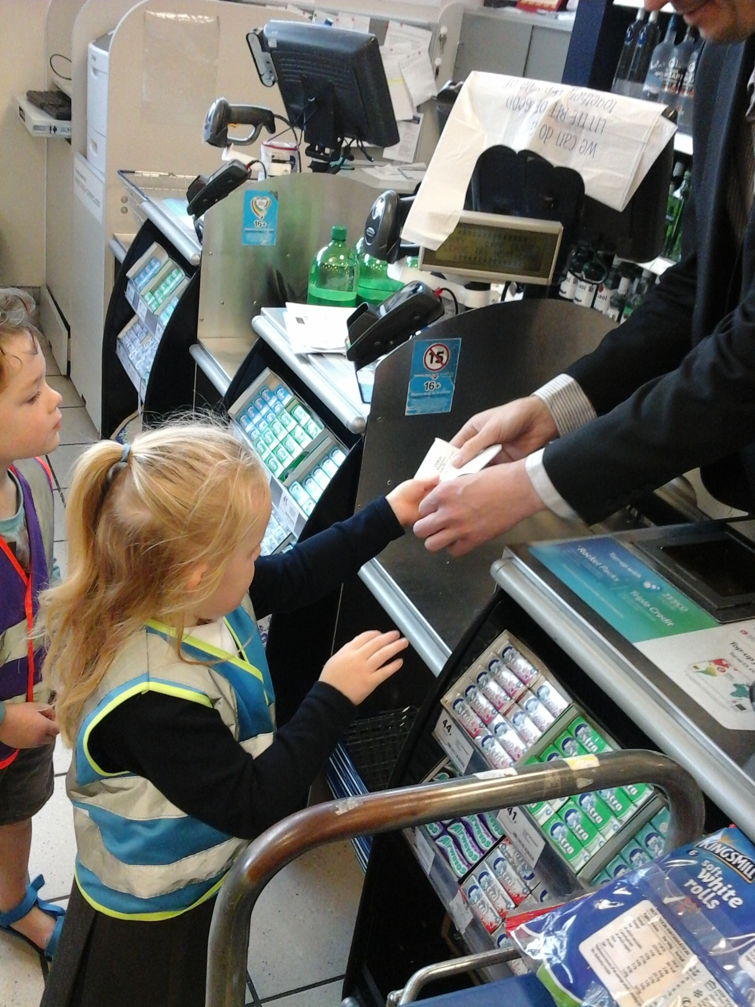Upcoming Events

January 23
Chinese New Year Week

March 2
Dr Seuss’s Birthday

March 27
Mother’s Day Mad Hatters Tea Party

June 16
Father’s Day Woodwork Workshop

July 19
Leavers Graduation

July 21
End of Summer Term

Welcome Back
Firstly we would like to welcome you all back after the Christmas holidays and wish you all a very Happy New Year. There have been a few staff changes to the Bridges room over the holidays and we would like to welcome Mrs Miller and Miss Regan to the team.
Dino Duckets and Wellie Racks
As more children have joined our room we have had to change how we store our shoes and slippers. Some children will be sharing pegs, as they are in on different days/times. Children’s indoor shoes/slippers are to be kept in the racks by the door and the ‘Dino Duckets’ are to be used for the children’s work and letters. Due to the current weather, could you please send your child in named wellington boots for outings and outdoor play.

Bridges Children Fund Box
The children have created a new money box for our room to collect for the children’s fund. The children’s fund is used to pay for new equipment and resources that will benefit the children’s learning and development. As most children receive free childcare and education, the money raised is vital for providing enrichment experiences. So far we have been able to purchase staging at cost of £1250, soft play at £500 and we were also able to hire an entertainer, Mr. Windbags, for the Christmas party All we ask for is a weekly voluntary contribution of £1. We thank you in advance for your continuing support. The Friends of Shotley Bridge Nursery School have also been instrumental in raising money. If you would like to be involved, please speak to a member of staff.

WOW Moments
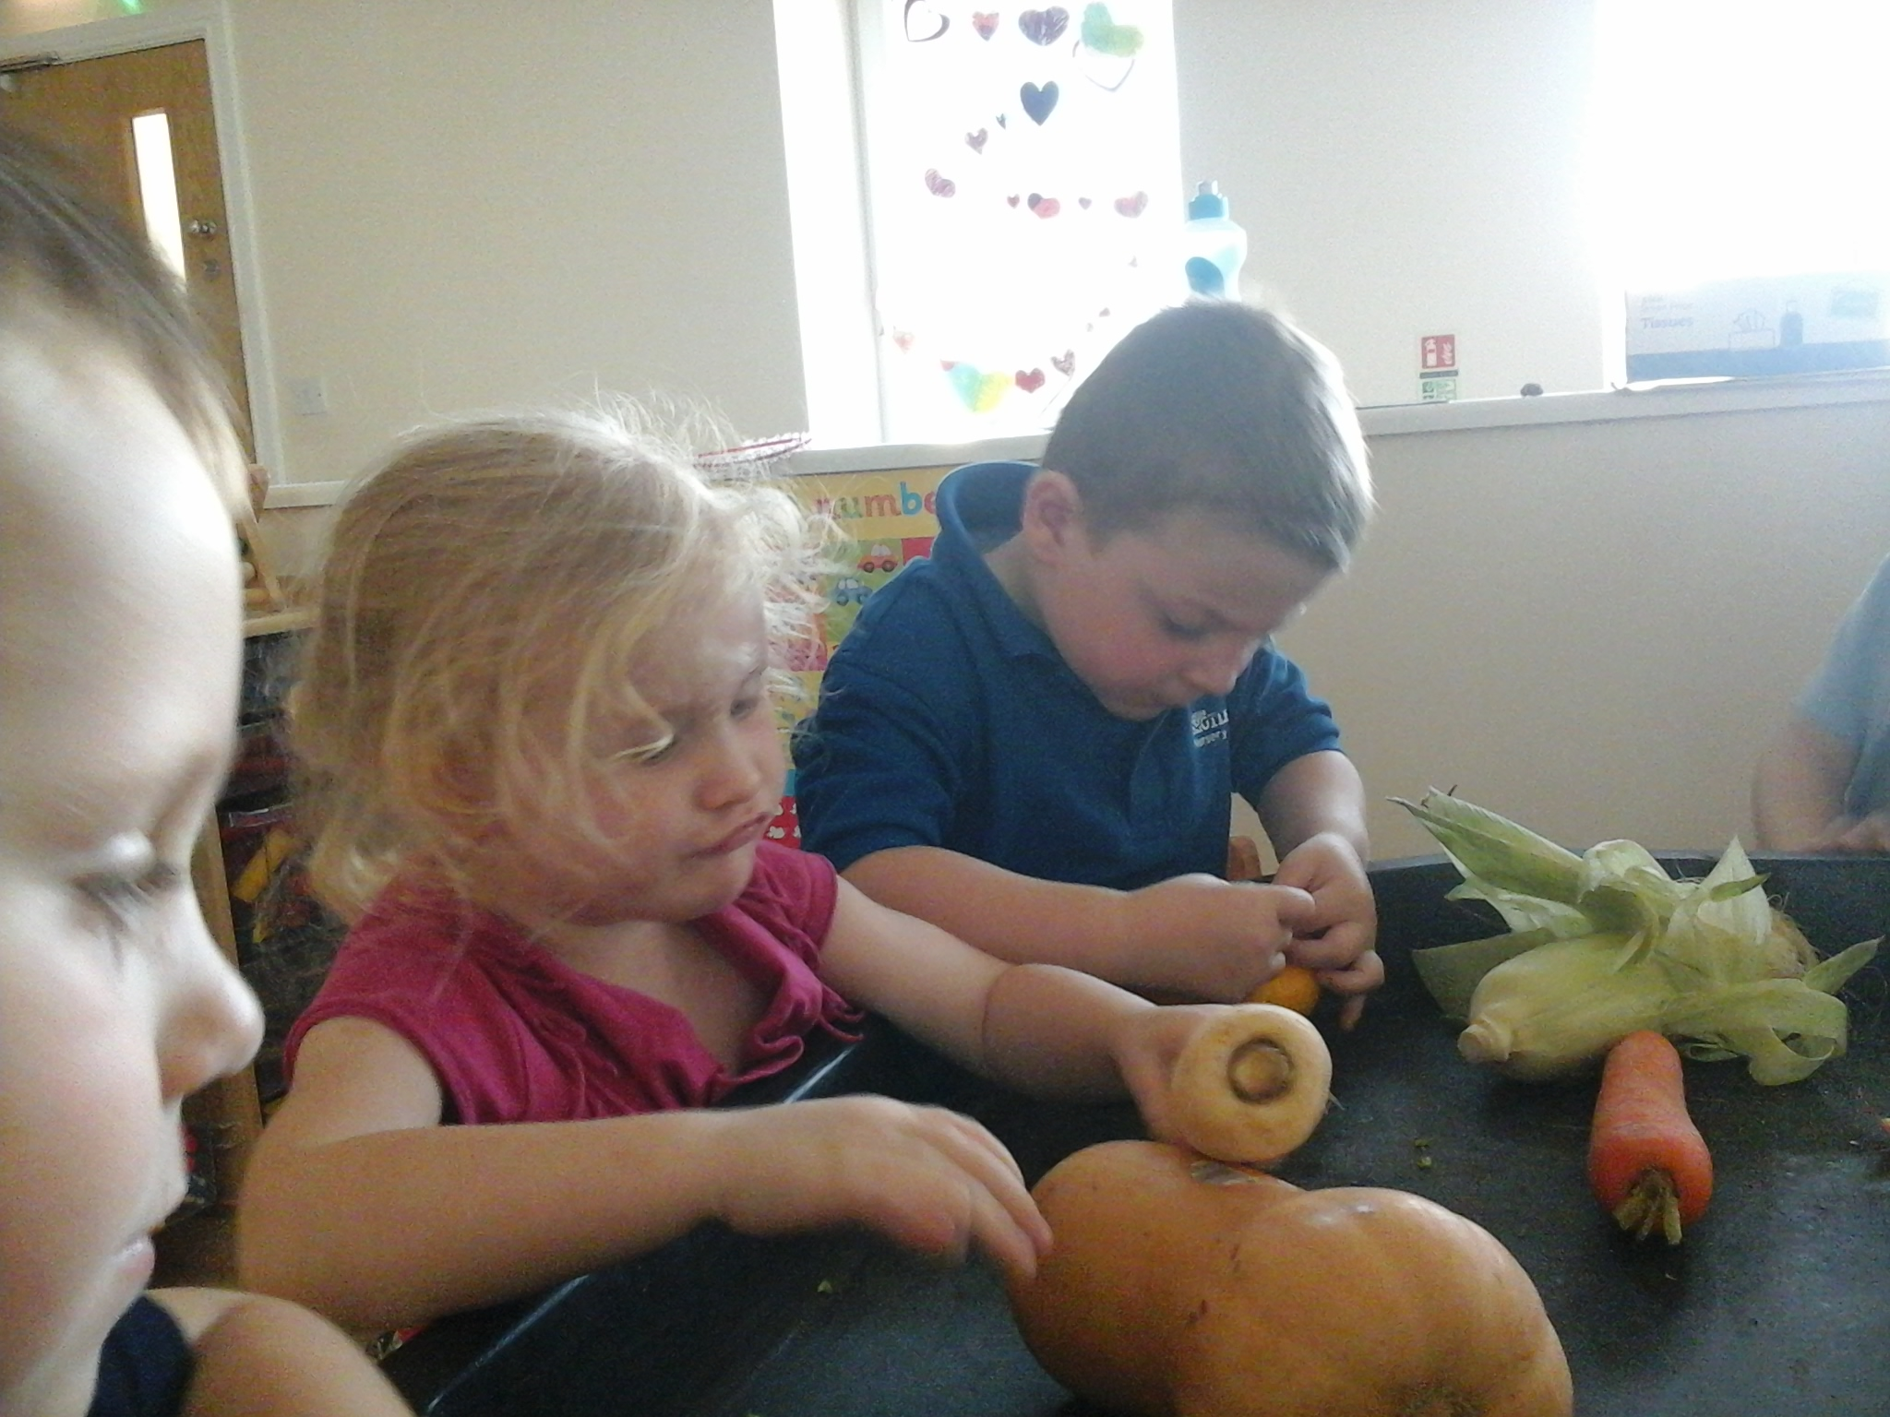

Any Other News
Please remember to name all your child’s clothing.
Please can you take your child’s water bottle home on a daily basis so they can be cleaned and replenished with WATER!
We have a lot of children bringing toys in from home, unfortunately we do not have the space to store them. Please can toys remain at home.
Please can you send in a named pack of baby wipes with your child
We need to replenish our stock of spare clothing (age 3-5); if you have any donations of socks, pants, trousers and tops we would be very grateful

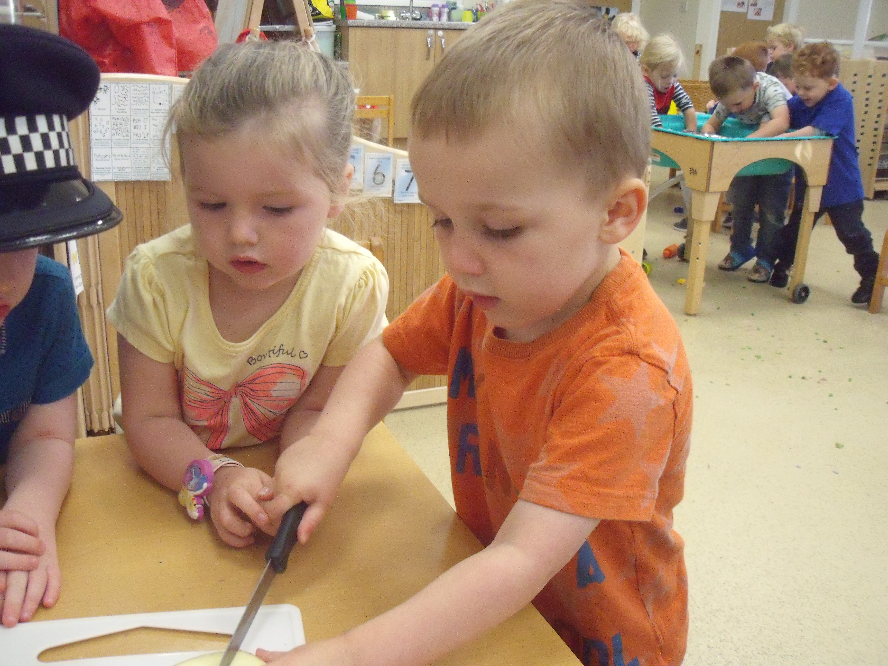
What we are learning
January 2017 - Colour, pattern and texture.

February 2017 - Shape and Measure.

March 2017 - Rhyme and Rhythm.

We love the wow moments that you have been sharing. As well as learning about your child’s achievements, those small pieces of paper give your child a sense of pride. Please continue to share. The WOW moment slips of paper are available in the room.
What we need
We really like to be creative and imaginative! To promote our learning we would like to extend a few of our collections with your help:
- Paper
- Old scales
- Beads
- Old watches/clocks
- Plastic cups and beakers
- Foreign coins
- Small World Figures and Animals

Breakfast
Please be aware that we stop serving breakfast at 8.15am. If your child arrives after 8.15am breakfast will have been cleared away and the daily activities will have begun.
Maths Challenge Homework
As part of the maths challenge we require parental involvement to support children’s mathematical development in the home environment. An email was sent out last week explaining how bath time can be used to enhance children’s learning. If you have not yet received the email or wish to discuss the homework, please talk to your child’s key person. We look forward to receiving your feedback.
Please remember our door policy and procedure. You must buzz the room individually and not let other people in at the same time. This is for safeguarding purposes. We appreciate that people are often in a hurry but please respect this system. On occasion parents have experienced someone being rude and aggressive when they have shut the door behind them. This is NOT ACCEPTABLE.

Follow us on Facebook and our website for more updates and photos of what is happening at nursery!

