Bridge’s Newsletter

October 2015

What we need

We like to use loose parts to promote our learning and currently we would like to extend a few of our collections with your help:

* Keys
* Bottle tops and milk tops
* Toilet roll tubes
* Wool

New Library

We would like to provide you and your child with the opportunity to borrow books from the nursery. In order for us to do this we need new or nearly new books. If you, family or friends have any books that you would like to donate we would be very grateful.

Helping your child to become independent.

Your child now has access to a free flow environment. This means they are able to access the outdoors independently. We are trying to make sure that your children are supported in everyday routines, such as dressing, changing shoes and putting on coats.

Today is such a fast society that we often overlook children trying to put on their own coats and shoes. Please can you ensure that all the children are supported in changing their own shoes and are able to put on their own shoes and coats, as well as ensuring that your child is dressed in clothing that allows them to easily access the toilet.

WOW Moments

We would like to introduce Wow moments. You can use these to inform us when your child does something for the first time or learns something new, such as:

* Begins to use the toilet independently
* Can get dressed by themselves
* Can share independently
* Learns new words or meanings
* Understands looking at books
* Recognising numbers or letters etc.

Pleas fill out WOW statements so we can all celebrate their achievements.

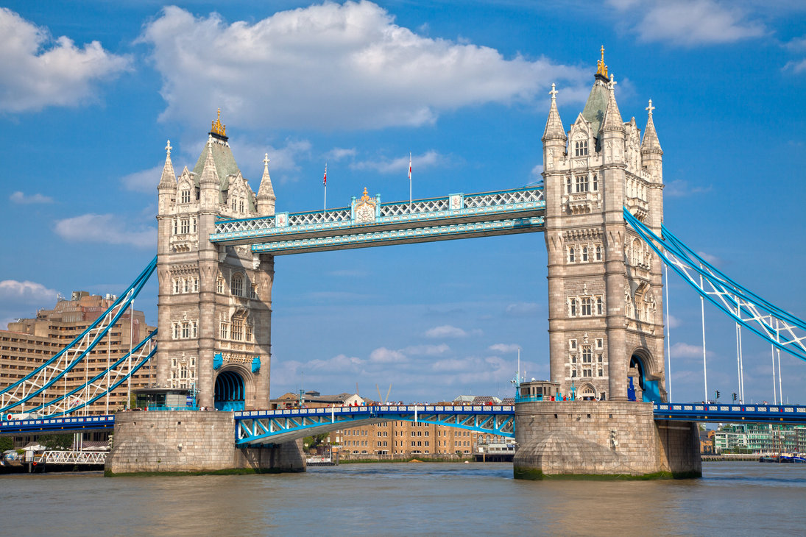

Guess the Bridge?

Photographs

Sarah Thew will be coming to take the children’s photos on the 4th November. Please talk to a member of the Bridge’s room if you would like to have a sibling photograph.

Any Other News

***Please remember to name all your child’s clothing****.*

If you have moved house, got a new mobile, changed doctor etc… please remember to tell us about these changes so we can update our contact information.

***Please can you send your child in with a named water bottle each day so that they can independently access water if they are thirsty***

What we are Learning

**October:**

5th-10th: Letter E

Number 5

3 Billy goats gruff - Looking at size differences and design and technology

12th-17th Letter F

Number 6

3 Billy goats gruff – Looking at bridges and how to make structures

19th-23rd Letter G

Number 7

The 3 pigs – Talking about feelings and understanding of the three pigs building experiences.

26thth-30th Halloween

Having fun exploring the meaning of Halloween